Multiple-choice section

|  |  |  |  |  |  |  |  |  |  |  |
| --- | --- | --- | --- | --- | --- | --- | --- | --- | --- | --- |
| Question | 1 | 2 | 3 | 4 | 5 | 6 | 7 | 8 | 9 | 10 |
| Answer | D | B | A | C | C | D | A | B | B | B |

Question 1 [9.1]

**D**

The highest power that appears in a quadratic equation is 2 (a squared term). **D** has a term raised to the power of 3.

Question 2 [9.3]

**B**

For the translated equation *y* = (*x –* 2)2 + 4

-2: a translation of 2 units to the right

+4: a translation 4 units up.

Question 3 [9.1]

**A**

The graph is a parabola.

Question 4 [9.3]

**C**

The dilation factor is the coefficient of the squared term. It is represented by *a* in   
*ax*2 + *bx* + *c*. The coefficient is -7, so the dilation factor is -7.

Question 5 [9.4]

**C**

The equation of a circle is *x*2 + *y*2 = *r*2. The equation that would graph as a circle is *x*2 + *y*2 = 4.

Question 6 [9.2]

**D**

*x*(*x* + 12) = 0

*x* = 0 or *x* + 12 = 0

*x* = -12

*x* = 0 or *x* = -12

Question 7 [9.6]

**A**

= , = so *k* = 

Substitute *k* into *y* = *kx*

*y* = *x*

Check with a value in the table.

Where *x* = 6:

*y* =  × 6

*y* = 1

Question 8 [9.4]

**B**

The graph of a circle is represented by the equation: (*x – h*)2+ (*y – k*)2 = *r*2 where *h* = 3 and *k* = 0. The centre is at (3, 0).

To find the radius we take the square root of the *r*2 term. = 11. The radius is 11.

Question 9 [9.5]

**B**

The power of x in the equation for a hyperbola is 1.

Question 10 [9.6]

**B**

*p*  *q*2

*p* = *kq*2

Multiple-choice total marks: 10

Short answer section

Question 11 3 marks [9.1]

Answers can be read off the graph. Algebraic solutions are given below.

**(a)** Use, *y* = 4*x*2 – 4*x* – 3: *a* = 4 *b* = -4



Where *x* =  or 0.5:

*y* = 4 × ()2 – (4 × ) – 3

*y* = (4 × 0.25) – 2 – 3

*y* = -4

Turning point is (0.5, -4).

**(b)** To find the *x*-intercepts, let *y* = 0.

*y* = 4*x*2 – 4*x* – 3

0 = 4*x*2 – 4*x* – 3

0 = 4(*x*2 – *x* – 0.75)

0 = 4(*x* + 0.5)(*x* – 1.5)

0 = *x* – 1.5

*x* = 1.5

0 = *x* + 0.5

*x* = -0.5

*x*-intercepts are at (-0.5, 0) and (1.5, 0).

**(c)** To find the *y*-intercept, let *x* = 0.

*y* = 4*x*2 – 4*x* – 3

*y* = 4 × 02 – 4 × 0 – 3

*y* = -3

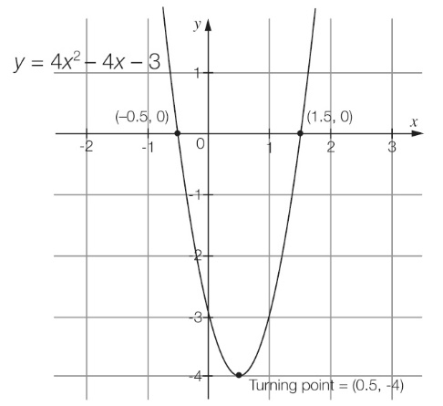

**(d)** The axis of symmetry is the *x*-value of the turning point (*x* = 0.5).

Question 12 8 marks [9.1]

**(a)** *y* = -*x*2 – 6*x* – 10

|  |  |  |  |  |  |  |  |
| --- | --- | --- | --- | --- | --- | --- | --- |
| *x* | -6 | -5 | -4 | -3 | -2 | -1 | 0 |
| *y* | -10 | -5 | -2 | -1 | -2 | -5 | -10 |

**(b)**

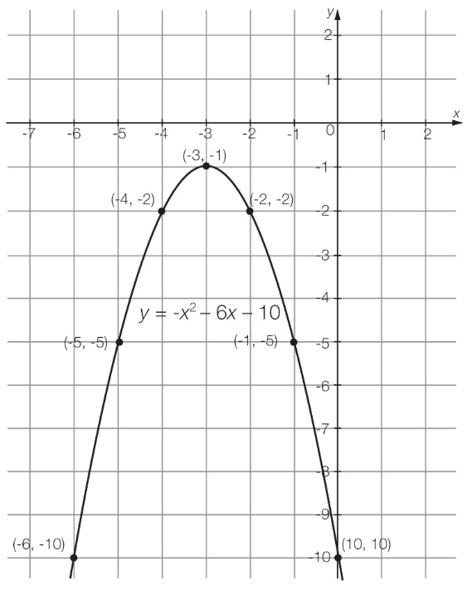

**(c)** From the graph, the turning point is (-3, -1).

**(d)** maximum turning point

Question 13 3 marks [9.2]

|  |  |  |
| --- | --- | --- |
| **(a)** (*x* – 5) (*x* + 2) = 0  *x* – 5 = 0 or *x* + 2 = 0  *x* = 5 or -2 | **(b)** *x*2 – 6*x* = 0  *x*(*x* – 6) = 0  *x* = 0 or *x* – 6 = 0  *x* = 0 or 6 | **(c)** *x*2 – 49 = 0  (*x* – 7) (*x* + 7) = 0  *x* = 7 or -7 |

Question 14 4 marks [9.2]

|  |  |
| --- | --- |
| **(a)** *x*2 – 12*x* + 27 = 0  (*x* – 9)(*x* – 3) = 0  *x* – 9 = 0 or *x* – 3 = 0  *x* = 9 or 3 | **(b)** *x*2 + 3*x* = 10  *x*2 + 3*x* – 10 = 0  (*x* – 2)(*x* + 5) = 0  *x* – 2 = 0 or *x* + 5 = 0  *x* = 2 or -5 |

Question 15 2 marks [9.2]

*y* = 4*x*2 + 21*x* + 5

4*x*2 + 21*x* + 5 = 0

(4*x* + 1)(*x* + 5) = 0

4*x* + 1 = 0

*x* = - *x*

*x* + 5 = 0

*x* = -5

*x*-intercepts are at (-, 0) and (-5, 0).

Question 16 6 marks [9.3]

|  |  |  |  |  |  |
| --- | --- | --- | --- | --- | --- |
|  | Equation | Dilation  factor | Reflection in *x*-axis | Translation in *x*-direction | Translation in *y*-direction |
| **(a)** | *y* = (*x* – 4)2 + 1 | *a* = | No reflection | Translated  4 units to the right | Translated  1 unit up |
| **(b)** | *y* = 2(*x* – 1)2 – 3 | *a* = 2 | No reflection | Translated  1 unit to the right | Translated  3 units down |
| **(c)** | *y* = -2(*x* + 1)2 + 3 | *a* = -2 | Reflection (upside down) | Translated  1 unit to the left | Translated  3 units up |

Question 17 2 marks [9.3]

**(a)** *y* = *x*2

*a* = +7, *h* = +12, *k* = +8

*y* = 7(*x* + 12)2 + 8

**(b)** *y* = *x*2

*a* = +, *h* = -1, *k* = -2

*y* = (*x –* 1)2 – 2

Question 18 3 marks [9.4]

*x* min = -4, *x* max = 2, *y* min = -5, *y* max = 1





centre: (-1, -2)



*h* = -1, *k* = -2, *r* = 3

(*x – h*)2 + (*y – k*)2 = *r*2

(*x* – (-1))2 + (*y* – (-2))2 = 32

(*x* + 1)2 + (*y* + 2)2 = 9

Question 19 1 mark [9.4]

(*x* + 5)2 + (*y* + 3)2 = 36

*h* = 5, *k* = 3, *r* = 6

translation: *h* = + 2, *k* = -6 *r* = 5

(*x – h*)2 + (*y – k*)2 = *r*2

(*x* + 7)2 + (*y* – 3)2 = 25

Question 20 4 marks [9.5]

**(a)** It represents an exponential relationship.

**(b)** *y*-intercept: (0, -1)

**(c)** asymptote

**(d)** Exponential graphs will always have a value that they will get closer and closer to but never reach. This value is called the asymptote of the graph.

Question 21 5 marks [9.6]

**(a)** The relationship could be directly proportional, because as *x* is increasing, *y* is also increasing.

**(b)** y = kx

8 = 2k

k = 4

24 = 6k

k = 4

equation: y = 4x

**(c)** Where y = 20 :

20 = 4 × x

x = 5,

Where x = 10:

y = 4 × 10

y = 40

|  |  |  |  |  |
| --- | --- | --- | --- | --- |
| *x* | 2 | **5** | 6 | 10 |
| *y* | 8 | 20 | 24 | **40** |

Short answer total marks: 41

Extended answer section

Question 22 8 marks [9.1]

**(a)** *h* = -*t*2 + 4*t*

|  |  |  |  |  |  |
| --- | --- | --- | --- | --- | --- |
| *t* | 0 | 1 | 2 | 3 | 4 |
| *h* | 0 | 3 | 4 | 3 | 0 |

**(b)**

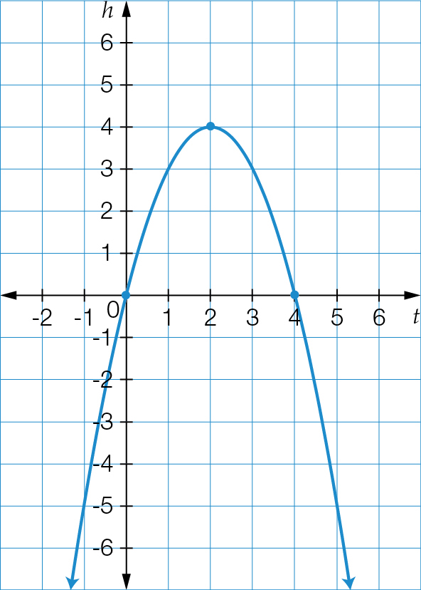

**(c)** From the graph, the maximum height of the ball is 4 m.

**(d)** From the graph, the ball reaches its maximum height at 2 seconds.

**(e)** From the graph, the ball hits the ground at 4 seconds.

**(f)** From the graph, the ball is 3 metres above the ground at 1 second.

Question 23 8 marks [9.4]

**(a)**

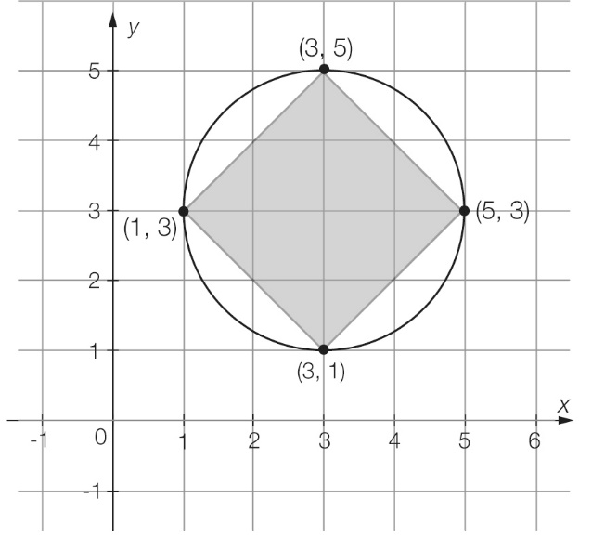

**(b)** *x* min = 1, *x* max = 5, *y* min = 1, *y* max = 5





centre: (3, 3)



*h* = 3, *k* = 3, *r* = 2

(*x – h*)2 + (*y – k*)2 = *r*2

(*x* – 3)2 + (*y* – 3)2 = 22

(*x* – 3)2 + (*y* – 3)2 = 4

**(c)** Area of kite

*A =**xy*

*A* =  × 4 × 4

*A* = 8 m2

Area of circle

*A = πr2*

*A* = π × 22

*A* = 12.566 m2

Area of garden bed = area of circle – area of kite

*A* = 12.566 – 8

*A* = 4.566 m2

Question 24 6 marks [9.5]

**(a)** Using the general equation for a hyperbola:*y* =  + *k*

*a* = 1, *x* = 2 and *y* = 1

The equation is:*y* =  + 1

**(b)** *x*-intercept occurs when *y* = 0

0 =  + 1

-1 = 

-1(*x* – 2) = 1

-*x* + 2 = 1

-*x =* -1

*x =* 1

(1, 0)

**(c)** *y*-intercept occurs when *x* = 0

*y* =  + 1

*y* = - + 1

 *y* = 

(0, )

**(d)**

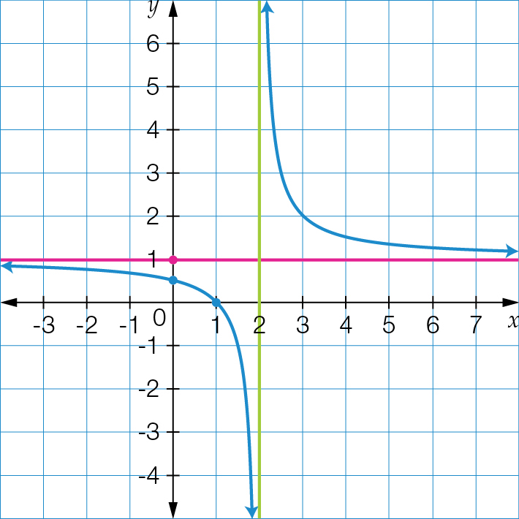

Question 25 8 marks [9.5] [9.6] [9.7]

**(a)** The volume is increasing whilst the pressure is decreasing, therefore, this could be inverse proportion.

**(b)** 

250 = 

*k* = 5000

**(c)** Equation: *P* = 

**(d)** When the volume is 8 L the pressure is

*P* = 

*P* = 

*P* = 625 kPa

When the volume is 10 L the pressure is:

*P* = 

*P* = 500 kPa

|  |  |  |  |  |
| --- | --- | --- | --- | --- |
| Volume (*V*) | 2 | 4 | 8 | 10 |
| Pressure (*P*) | 2500 | 1250 | **625** | **500** |

**(e)**

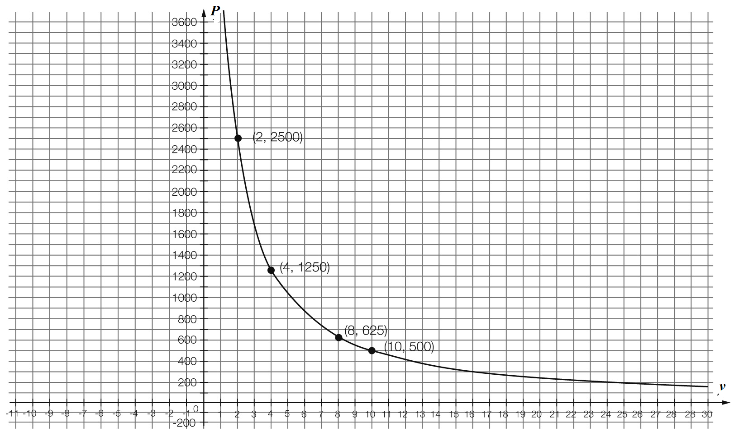

**(f)** The relationship is an example of inverse proportion as the graph is hyperbolic and has the equation . Also, as the volume is increasing, the pressure is decreasing.

**(g)** *P* = 

2000 = 

2000*V* = 5000

Therefore, *V* = 2.5 L

Extended answer total marks: 30

TOTAL test marks: 81